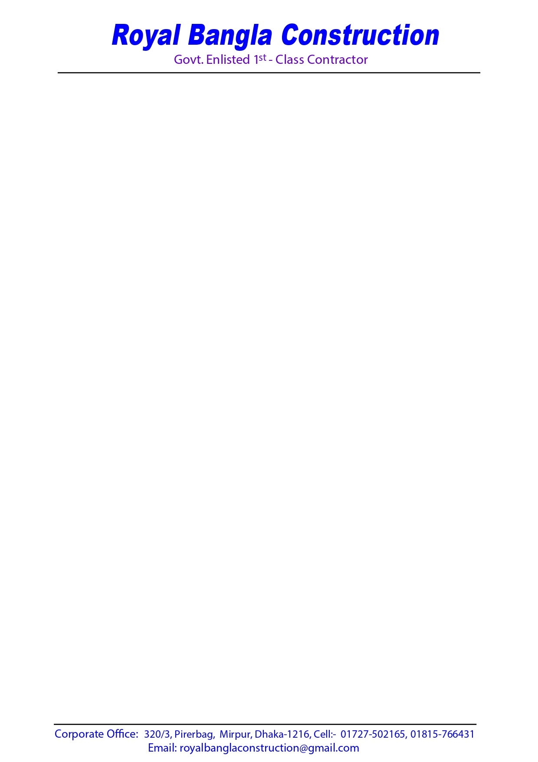

05th September, 2023

To

Executive Engineer,

LGED, 62 West Agargaon,

Sher-e-Bangla Nagar, Dhaka.

**Sub: Declaration of Authorizing Signatory.**

|  |
| --- |
| Invitation for Tender No: LGED/IRIDP-3 APP ID:195165, |
| Tender Package No: IRIDP-3/DHK/DW-97 |

e-GP ID: 862884

Dear Sir,

I, do hereby declare that I, M. Kamrus Saleh, Owner of the firm Royal Bangla Construction, NID No- 19882699039530409, myself signed all the tender documents bearing ID- 862884 with the authority to make decisions in all the matters that concern the quality of work that is carried out for Tender.

**For Royal Bangla Construction**

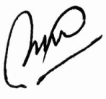

**Royal Bangla Construction**

Proprietor

Cell- 01815 766431



05th September, 2023

To

Executive Engineer,

LGED, 62 West Agargaon,

Sher-e-Bangla Nagar, Dhaka.

**Sub: Declaration of Authorizing Signatory.**

|  |
| --- |
| Invitation for Tender No: LGED/GoBM/ APP ID: 194433, |
| Tender Package No: e-Tender/LGED/DHA/GOBM/23-24/W-01 |

e-GP ID: 862879

Dear Sir,

I, do hereby declare that I, M. Kamrus Saleh, Owner of the firm Royal Bangla Construction, NID No- 19882699039530409, myself signed all the tender documents bearing ID- 862879 with the authority to make decisions in all the matters that concern the quality of work that is carried out for Tender.

**For Royal Bangla Construction**



**Royal Bangla Construction**

Proprietor

Cell- 01815 766431



05th September, 2023

To

Executive Engineer,

LGED, 62 West Agargaon,

Sher-e-Bangla Nagar, Dhaka.

**Sub: Declaration of Authorizing Signatory.**

|  |
| --- |
| Invitation for Tender No: LGED/GoBM/ APP ID: 194433, |
| Tender Package No: e-Tender/LGED/DHA/GOBM/23-24/W-02 |

e-GP ID: 862880

Dear Sir,

I, do hereby declare that I, M. Kamrus Saleh, Owner of the firm Royal Bangla Construction, NID No- 19882699039530409, myself signed all the tender documents bearing ID- 862880 with the authority to make decisions in all the matters that concern the quality of work that is carried out for Tender.

**For Royal Bangla Construction**



**Royal Bangla Construction**

Proprietor

Cell- 01815 766431



05th September, 2023

To

Executive Engineer,

LGED, 62 West Agargaon,

Sher-e-Bangla Nagar, Dhaka.

**Sub: Declaration of Authorizing Signatory.**

|  |
| --- |
| **Invitation for Tender No: LGED/IRIDP-3 APP ID:195165,**  **Tender Package No: IRIDP-3/DHK/DW-96** |

**e-GP ID: 862883**

Dear Sir,

I, do hereby declare that I, M. Kamrus Saleh, Owner of the firm Royal Bangla Construction, NID No- 19882699039530409, myself signed all the tender documents bearing ID- 862883 with the authority to make decisions in all the matters that concern the quality of work that is carried out for Tender.

**For Royal Bangla Construction**



**Royal Bangla Construction**

Proprietor

Cell- 01815 766431



05th September, 2023

To

Executive Engineer,

LGED, 62 West Agargaon,

Sher-e-Bangla Nagar, Dhaka.

**Sub: Declaration of Authorizing Signatory.**

Invitation for Tender No. LGED/IRIDP-3 APP ID:195165,

Tender Package No: IRIDP-3/DHK/DW-98

e-GP ID: 862885

Dear Sir,

I, do hereby declare that I, M. Kamrus Saleh, Owner of the firm Royal Bangla Construction, NID No- 19882699039530409, myself signed all the tender documents bearing ID- 862885 with the authority to make decisions in all the matters that concern the quality of work that is carried out for Tender.

**For Royal Bangla Construction**



**Royal Bangla Construction**

Proprietor

Cell- 01815 766431